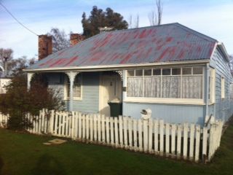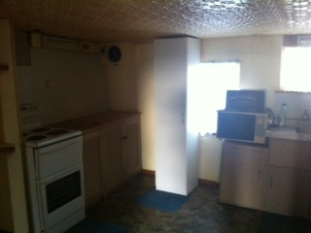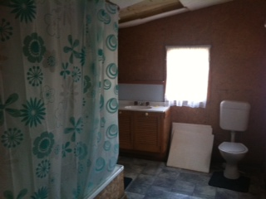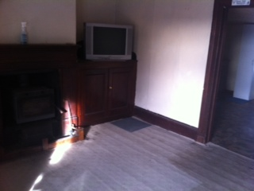

**16 Elizabeth Street, BOTHWELL TAS 7030**

**3 Bedroom Weatherboard Cottage**

This cottage style house was constructed in the 1840's features three bedrooms, freestanding wood heater, enclosed easy maintainable yard. For country living a must for inspection.

9917445

**$165**